DEPARTMENT OF CIVIL ENGINEERING
ACTIVITIES OF DEPARTMENT ASSOCIATION PACE

ACADEMIC YEAR 2020-21

- Webinaron ‘Scope of Civil Engineering’ was conducted for plus two students from various schools and 3rd semester (2019 batch) students on 17/8/2020 from 11 am – 12.30 pm. The speaker was Ms. Aarya K R, Manager, Corporate Relations, Civilianz. 36 students from various schools attended the webinar. It was very informative.

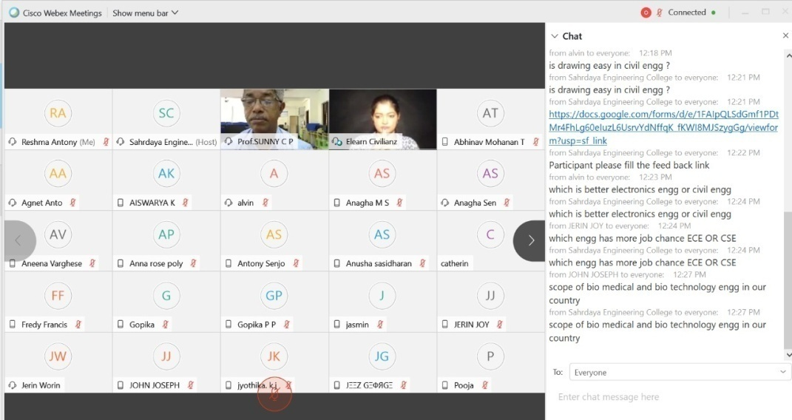

- Webinar on ‘Career Opportunities for Civil Engineers’ was conducted for 5th semester, 7th semester and outgoing batch students (2018, 2017 and 2016 batch) on 19/8/2020 from 11 am – 12.30 pm. The speaker was Ms. Aarya K R, Manager, Corporate Relations, Civilianz. By this webinar the students got an idea regarding various opportunities after completing the course.

- Alumni interaction (online) was conducted for the third semester students (2019 batch) on 19/9/2020 from 1.30-2.30pm. The speaker was Ms. Riya Susan Andrew, Alumnus, 2013 -17 batch who just completed working M Tech in Computer Aided Structural Analysis and Design , Dept of Ship Technology, CUSAT. The talk was very interactive. Ms Riya shared her experiences in the college and how to utilize all the resources available in the college.

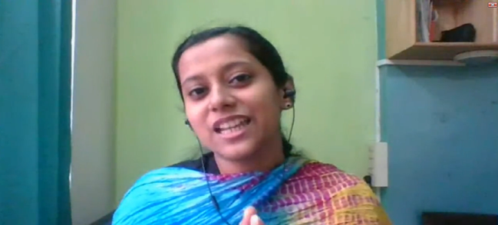

- Alumni interaction (online) was conducted for the seventh semester students (2017 batch) on 25/9/2020 from 1.30-2.30 pm. The speaker was Ms. AmruthaShaji, Alumnus, 2015 -19 batch who is working as Road Engineer, Qatar Design Consortium, Qatar. She shared her experience in sites, neew working environment etc to the students.

- Webinar on ‘Vaastu for construction’ was conducted for 7th and 5thsemester students (2017 and 2018 batch) on 17/10/2020 from 1.30pm – 2.30 pm. The speaker was Mr. Vishnudas, Vaastu consultant and Building designer, BRICS. The speaker gives an introduction to Vaastu, its importance in construction and some basic things in Vaastu for construction. Students asked their doubts and it was well clarified.

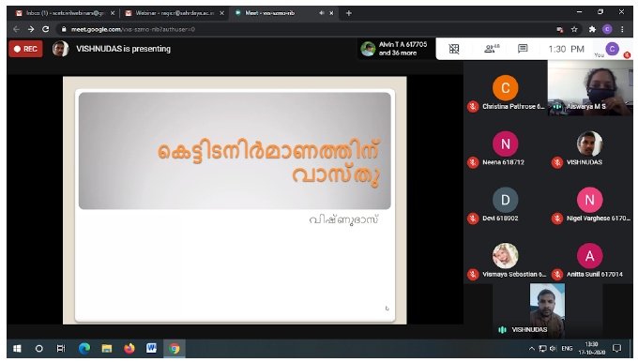

- Webinar on ‘An introduction to Earthquake Engineering’ was conducted for 7th semester students (2017 batch) on 30/10/2020 from 2 pm – 3 pm. The speaker was Dr. Reshmi Sebastian, IIT Ropar. Meeting was very interactive. Topic was new to the students.

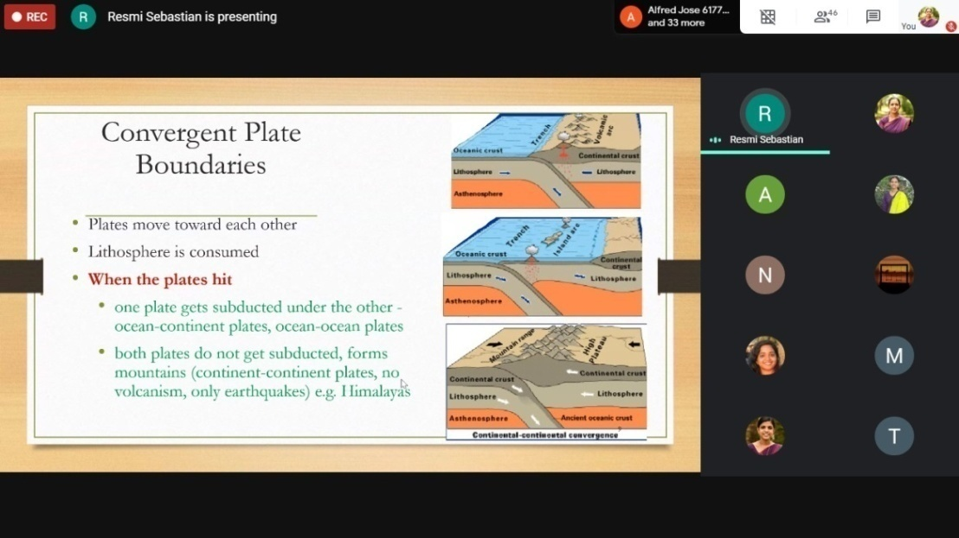

- Alumni interaction (online) was conducted for the all students on 06/11/2020 from 1.30-2.30 pm. The speaker was Ms. Anjana K, Alumnus, 2013 -17 batch who is working as Senior Engineer, L&T Construction. Ms.Anjana shared her experience in L & T, her interview experience etc. Students were very interactive for the session.

- PACE in association with HR Department conducted Industry interaction (online) on ‘Post Covid Era- Challenges and Opportunities’ for all students on 13/11/2020 from 10 am – 11 pm. The speaker was Mr Mahesh L, Chief Technical Officer, Asset Homes

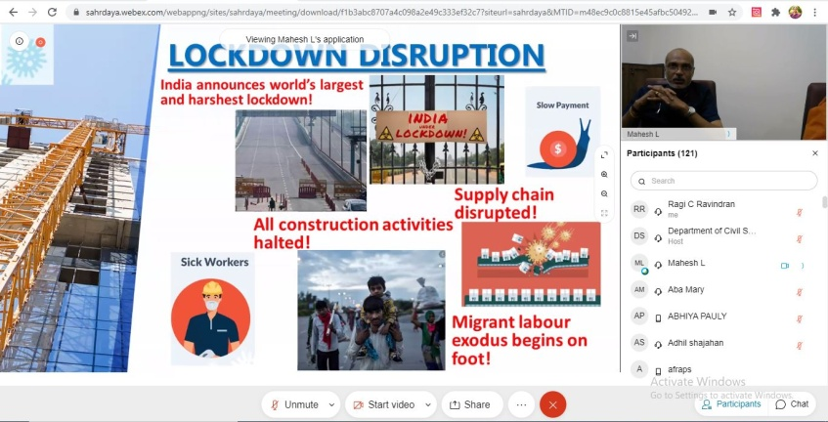

- 5-day Faculty Development program (online) on “Recent Advancements in Civil Engineering- RACE2020” was from conducted 28/12/2020 to 01/01/2021. The participants include faculties from other institutions. It include total ten sessions by various experts;

Name of the speaker | Details | Topic
Dr. Katta Venkataramana | Professor, Dept. of Civil Engineering, NITK , Surathkal | Introduction to Earthquake Engineering (Keynote)
Er. Nisam Abubakkar Kuraisha | Senior Structural Engineer,WME Consultants,Dubai, U.A.E | Advancement in Construction site management, Inspection and supervision
Dr. Shreyasvi C | Post Doctoral Research Fellow, IIT Gandhinagar | Recent Advances in Earthquake Resistant Construction practices
Er.Abhijith | Project Manager, RWDI Consulting Engineers(India) Pvt. Ltd | Wind loading on tall buildings
Dr. Sreevalsa Kolathayar | Assistant Professor, Dept. of Civil Engineering, NITK , Surathkal | Civil Engineering Innovation towards UN SDGs- Resilient Infrastructure an dwater security
Er.Chackochan M V | Executive Engineer (Civil, Retd.), Kerala Agricultural University, Consultant- KIIDCO, Trivandrum; WAPCOS, Ernakulam | Future Development for Transportation Engineering
Mr Nogy Austine | Former GIS consultant, ESRI, Australia | Geograpghic information system
Er. Adheesh K R | Proposals Manager, L&T Constructions, Buildings and Factories | Project Delivery Methods
Dr. G R Reddy | Distinguished Scientist (Retired), BARC Mumbai ,and Adjunct Professor, NITK | Investigations on Hysteretic behavior of RC beam cloumn joints
Rahul M P | Manager (Design &PMC), PEAMS Engineering Consultant Pvt Ltd. | New Austrian Tunneling method (NATM)

- Online workshop on “Technical writing” was conducted on 26/04/2021 at 1.30 to 3.30 pm for 8th and 6thsemester students (2017 and 2018 batch). The speakers was Mr.Ciby Jacob Cherian and Ms. Haritha C R, Assistant professor(s), Dept. of Civil Engg. SCET

- Expert Lecture (online) on Application of Geographical Information System (GIS) in Civil Engineering Projects was conducted on 03/05/2021 from 10am to 12 pm for 4th and 6thsemester students (2019 and 2018 batch). The speakers was Ms. Reshmi K and Ms. Anjali M Nair, Senior Faculty, Centre for Geo Information Technology, Peringavu , Thrissur. The session covered the basics of Geographical Information System (GIS), components of GIS both hardware and software. An overview of GIS operations and data analysis, fundamentals of data interpretation and various GIS data models like vector and raster data models were also a part of discussion.

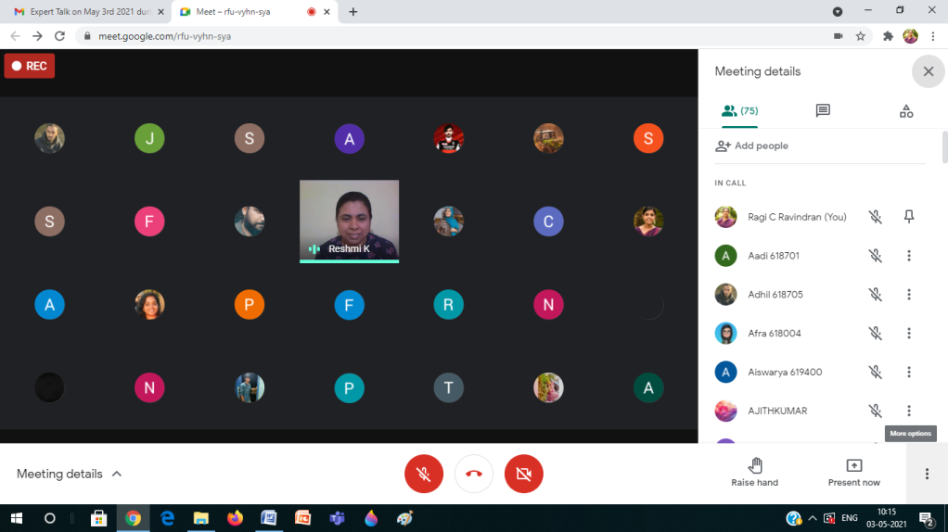

- Expert Lecture Talk (Online) on “Investigation of sustainable water use and water scarcity in India” was conducted on 04/05/2021 for 8th (2017 batch) students. The speaker was Dr Naveen Joseph (Post-Doctoral Fellow Idaho Water Resources Research Institute University of Idaho, USA)

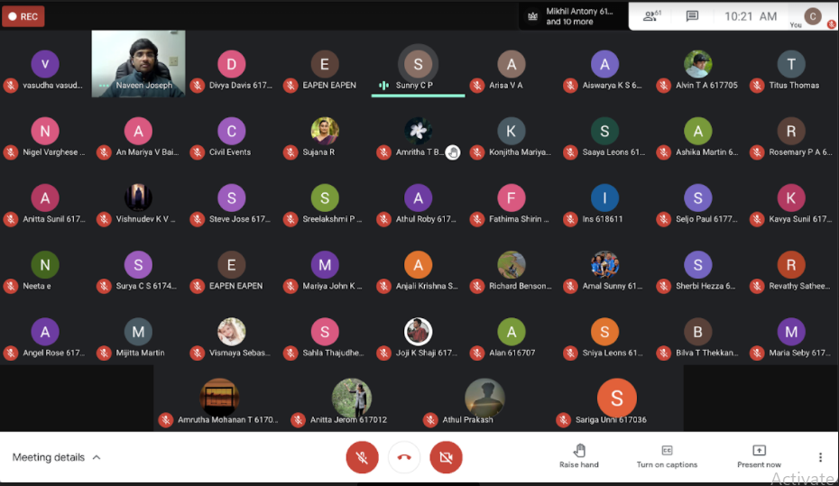

- Alumni interaction (online) was conducted for the all 8th semester (2017 batch) students on 11/05/2021. The speaker was Athulya Philo Joseph, Software trainee, Infosys, Alumnus batch 2015- 2019. Ms. Athulya shared her experience and challenges for working in IT sector after studying Civil Engineering.
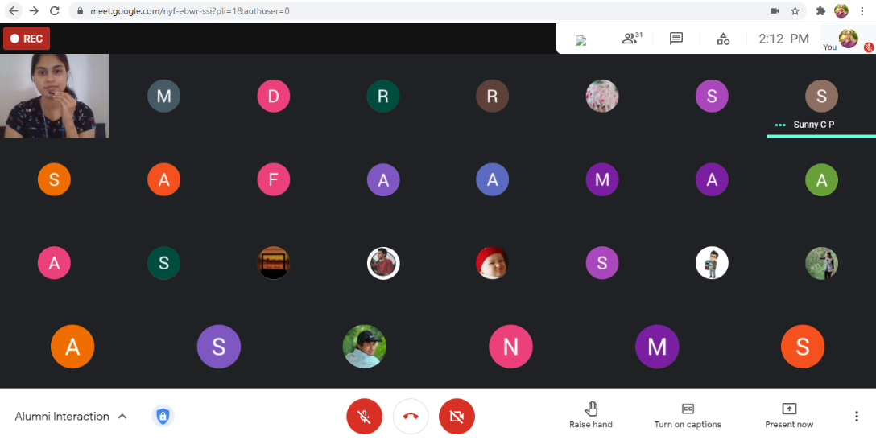

- Talk on OBE (online) was conducted for the all students (2017, 2018, 2019 and 2020 batch students) 28/05/2021. The speakers were Ms Remya P M, Ms Sujana, Mr Akhil S Nair and Mr Ciby Jacob Assistant professor(s), Dept. of Civil Engg. SCET. The concept of OBE and importance are delivered to the students by this session.

- Training session - 'Basics of Python' (online) was conducted for the all 4th semester (2019 batch) students on 03/06/2021. The speaker was Mr. C Willson Joseph, Faculty of CSE Department, Sahrdaya College of Engineering & Technology. The session was conducted about 2 hours in which basic concept of python was delivered to students.

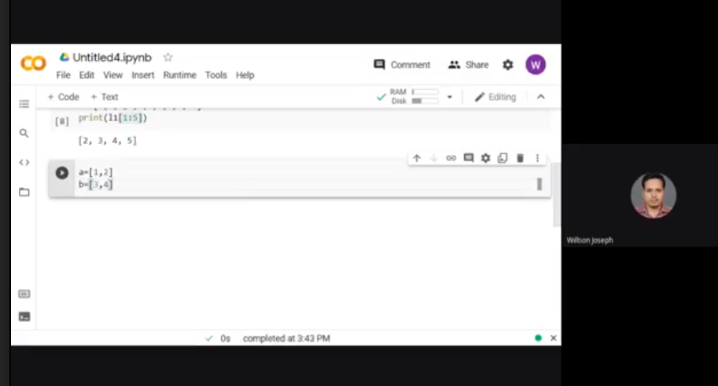

- Webinar on “Construction of Kannur International Airport - A Case Study” was conducted for the all 6th and 4th semester (2018 and 2019 batch) students on 04/06/2021. The speaker was Malavika S, Research Scholar, College of Engineering, Pune. The session was very informative and students interacted well.

- Online quiz on Natural disasters was conducted for plus two students was conducted on 05/06/2021 as part of world environment day. 63 students from various schools have participated in the event. Cash prize where given to those who secured first and second position.

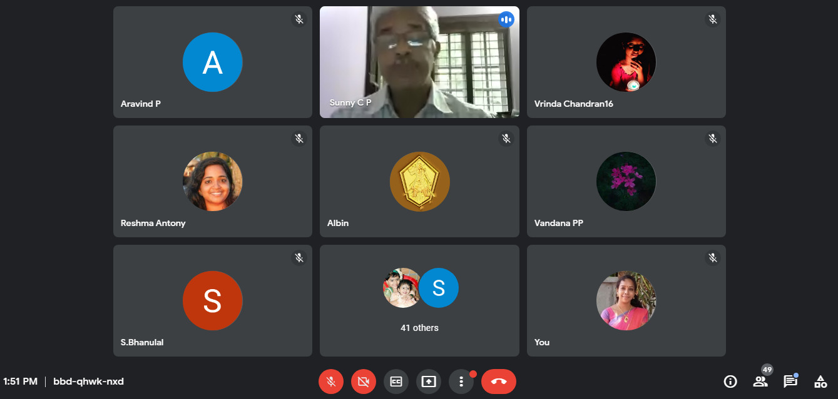

- Webinar on “Exploring possibilities in Civil engineering” was conducted for 4th semester (2019 batch) on 26/06/2021. The speaker was Neeraj C R, PhD Research Scholar, Indian Institute of Technology, Palakkad, Kerala. The speaker explained about various opportunities in government, public sectors, entrepreneurship, higher studies etc. to the students.
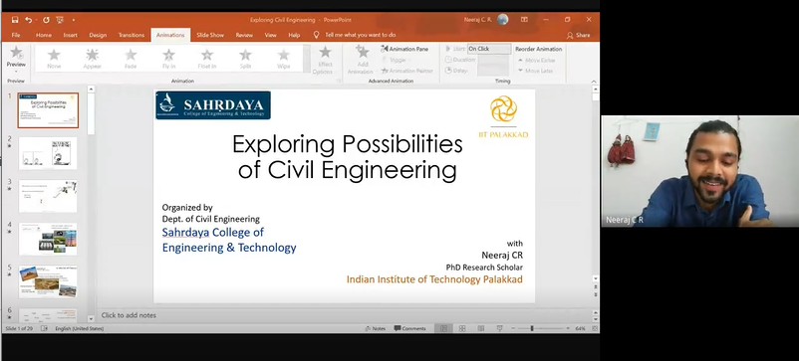

- Webinar on “Exploring possibilities in Civil engineering” was conducted for 4th semester (2019 batch) on 26/06/2021. The speaker was Neeraj C R, PhD Research Scholar, Indian Institute of Technology, Palakkad, Kerala. The speaker explained about various opportunities in government, public sectors, entrepreneurship, higher studies etc. to the students.

